EU Conflict Resolution Policy in the South Caucasus:
Paying for Security vs. Manipulation for Influence

Sona Margaryan
margaryan.sona@yahoo.com
Central European University

Abstract:

The importance of the resolution of “frozen” conflicts is on the agenda of different countries, international associations, NGOs, politicians and scholars. Analyzing conflicts from different aspects and operationalising the strategies under the built theoretical frameworks have become the main scientific approaches further implementable empirically on the state level.
Conflict resolution studies in the South Caucasus are connected with highly fragile towards conflicts role of the region, where all three countries of the region - Armenia, Azerbaijan and Georgia are considered as sides of severe conflicts. I address the conflicts of Nagorno-Karabakh and Abkhazian and South Ossetia under the combination of two conflict theories: Realist theory and Conflict Manipulation theory in the framework of regional dominant actors’ strategies and policies.
The realist theory states that the international security can be achieved through the actions of Great Powers, creating a regional balance where the conflicts evolve “by force” or by “geostrategic mediation”. Although the theory is considered to be “out-of-date”, I do see the applicability of the theory in the region, because of the steps of Russia, USA and EU taken to increase their influence in the region.
The second theoretical approach: the conflict manipulation not only looks at the involved in the conflict countries’ steps as conflicting sides but also is applicable to the foreign powers and their actions for getting more benefits from the conflict while manipulating in the most beneficial for them way.
The combination of the two theories makes the whole view more clear, while trying to explain the EU steps towards conflict resolution with uncertain position, vague and broad proposals, and avoidance to adopt strong position and support. I would call the combination of the realist and conflict manipulation theories “rational domination theory”, so far it is aimed at increasing or creating dominant strategies through different mechanisms in the conflicting countries, where the conflict intrinsically is the mechanism being used and manipulated.
Hypothesizing that the efforts of the European Union are not aimed towards the conflict resolution in the South Caucasus, but rather have symbolic character vaguely presented in the Action Plans signed with Armenia, Azerbaijan and Georgia.
The European Union, in line with economic, financial and political support to the countries in the region has its own interest and implements its policies for the sake of strengthening its role, while the conflict manipulation is the best way to grab from the conflicting sides as much resources, consensus and compromise as possible, meanwhile without showing any interest in solving the conflicts in the South Caucasus and without being able to identify its own strong position vis-à-vis other players in the region.
EU conflict resolution policy in the South Caucasus
Paying for security vs. manipulation for influence

Introduction

Approaching the EU policy in the South Caucasus from the manipulation and realist theory angles, I am introducing the idea hypothesized that the efforts of the European Union are not aimed towards the conflict resolution in the South Caucasus, but rather have symbolic character vaguely presented in the Action Plans signed with Armenia, Azerbaijan and Georgia.
The literature review and the in-depth analysis of cases serving as methodology for the paper, I develop the idea through introducing different theories and creating the rational domination theory that precisely reflects the EU policy in the South Caucasus aimed towards the resolution of the conflicts. Admittedly there are certain limitations and assumptions that make the model functioning in its complexity framework, meanwhile isolated. The main stream I am following is the theoretical analysis and the interpretation of the theory as an outcome of the judgment introduced.
Talking about the international intervention I should cite that confidence-building measures and international interventions are imperfect. By definition outside support internationalizes the conflict and significantly complicates it raising the costs and making it harder to solve. This is true and is the core that lies under my research.
The first idea I generate is the European World System, which is deducted from Wallerstein’s framework of World System theory, showing the place of the countries of the South Caucasus in the EU and after presenting brief definitions of conflicts and the international intervention, I will firstly introduce the logic of international intervention with extended deterrence theory followed up by the analysis under the framework of credible commitment theory, realist theory coming to the analysis of the outcomes via manipulation strategies and non-involvement non-case analysis.
I expect to fail to reject the hypothesis introduced, that means it will serve as bases for future research in approaching the topic from other angles in different contexts.

Research Design and methodology
The EU conflict resolution policy in the South Caucasus is one of the core topics in the field of research of ethnic conflicts and the geostrategic setup of the powers in the aforementioned region which is suffering from the “frozen” conflicts per se existence shattering the stability and the security of the region, preventing prosperous and peaceful coexistence of the countries of the region.
“Conflict occurs because some groups in a society perceive themselves to be politically or economically disadvantaged” and groups fight because at some point and in some circumstances violence becomes essential to achieve benefits.
The context I examine - the EU intervention, is associated with the action-system described by Johan Galtung, where the goal-states have incompatible interests in the system where a conflict is described as a property of an action-system comprising different actors with the smallest action-system - individual actor. Inter-state conflicts, described by Galtung, which are addressed by me in this paper, split the action-systems in parts, where subsystems appear, each of them defending their own goal-states.
Conflict resolution is a “a situation where the conflicting parties enter into an agreement that solves their central incompatibilities, accept each other’s continued existence as parties and cease all violent action against each other.” David Lake and Donald Rotchild intrinsically but not openly bring in the idea of conflict transformation, the term, that I will be using during the whole article, instead of conflict solution, so far the outcomes of any kind of conflict solution or settlement need long-term efforts to overcome hatred and stereotypes between the action-systems involved in the conflict. The intrinsic idea David Lake and Donald Rothchild mention is that management of ethnic conflicts by local elites, governments or international community is a continuous no end process that does not bring to final resolution - this is an imperfect process: it cannot be resolved. While talking about the peace settlement of the conflicts I will prioritize using the term conflict transformation, for the reason that it better describes the ex ante state-of-affairs of the conflict in its complexity of solutions and challenges, that make the solution incompatible with the current setup of the relations. While talking about the conflict transformation David Carment and Patrick James citing from Vayrynen’s framework, state that the process describes change in both domestic and foreign conflict systematically.
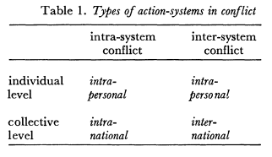
Source: Johan Galtung, Institutionalized Conflict Resolution: A Theoretical Paradigm, Journal of Peace Research, Vol. 2, No. 4 (1965), p. 348.
Given the framework by David Carment and Patrick James the main discussion follows the first stream of the possible paths the conflict management can take - Nonforceful crisis management techniques, including negotiation, adjudication or arbitration, mediation and nonmilitary pressure.
Admitting that the deterrence model gives an incomplete view of the relationships that the conflicting sides and the third party face in my article I ignore the strategic choices that the conflicting sides make, meanwhile ignoring the bargaining dynamics, whereas in my approach in the light of extended deterrence the assumption should be made that three strategic actors are involved in each conflict I examine: particularly the EU is a third-party player in each conflict and in case of Nagorno-Karabakh conflict the other two players are Armenia and Azerbaijan and in case of Abkhazia and South Ossetia the two openly involved sides are Georgia and Russia.

The European Model of World System

I start developing my ideas with making clear judgments on the place of the EU in the World-System and the place of the conflicts within the EU, creating and introducing a new concept of European World-System, that has been addressed numerous times, but not in the context of identifying conflicts in it.
Marian Borg in Conflict Management in the Modern World-System is analyzing the place of conflict management globally in correlation with the status of the states in the modern world-system according to the framework of Wallerstein’s world-system theory, specifying the core, periphery and semi-periphery. The argument of Borg is that the status of the nations in the world-system is correlated with the primary mode of conflict management they use at a given time. The arguments made by the author are the status of nations within the world-system at a specific time is correlated with the primary conflict management strategy and the strategy used affects the ranking of the nation. Applying the world-system theory to the model I am using and the scope of construction of the players around the discussed issue, the discussion will lead to two major directions: the first is firstly the ranking of the EU in the modern world-system and its means of conflict management used currently and the second approach is the identification of division of core, periphery and semi-periphery within the EU isolated from the rest of the world. Without trying to assess the EU rank in the modern world-system I will refer to the European Model of World-Economy as an application of the world-system theory of Immanuel Wallerstein “The inequalities of core and periphery”. Defining the world-system as a “unit with a single division of labor and multiple cultural systems”, I will apply the system “without common political system variety” to the European Union current economy system. In the light of world-economy system the division to “regions”: core, periphery and semiperiphery, the European world-economy is considered as the core having Russia, Spain, Japan on the semiperiphery and Latin America, Asia, Africa on periphery. I will apply the distinction inside the European Union. The best example for the EU can be the principles of “variable geometry” and “concentric circles”. The logic of the division in the capitalist world economy applied to the EU will concentrate in the core the “circle of shared law”: EU Member States, “adjacent circle” formed from the countries of semiperiphery in the name of potential candidate countries and the “more select circles”: countries which are tied with the EU with cooperation. But it is important to notice that back to the time the distribution of the countries on the circles was noticeably different from the one that exists now. The core is more industrialized and economically more independent from the countries on semiperiphery and periphery, but none of the countries controls the system, as it is a combination of common decision-making. Meanwhile the core is so powerful that can set the criteria, for example for EU membership (Maastricht Criteria: economic criteria for accession), which is impossible to be fulfilled even by Germany. Consequently the three countries of the South Caucasus – Armenia, Azerbaijan and Georgia fall into the category of peripherical countries for the European model of world-system with the meaning that the correlation of the rank of the countries and their potential for investing in the solution of own conflicts is relatively low. And with this consideration the EU as a sui generis entity can become a credible player for the conflict management to the extent it is interested in the security of its borders, prosperity and development. At the meantime this is not the reflection of reality because of the isolation from other major powers in the region for the first reason and the second reason is that more beneficial strategy for the EU is the manipulation with the conflicts because of impossibility to bias itself towards one of the sides and grabbing as much benefits from the region as possible.
In this system and generally the countries that are noncore, are highly dependent on the core. The conflicts of the South Caucasus are meant to be peripherical conflicts which are not of serious importance for the EU being literally on periphery as well. The proof of which is the description of the conflicts given below. The EU is unlikely to offer membership to the countries of the region even in a medium or long-term perspective but it does not have credible means to impose conditionality in the region: a problem that has to be addressed and a solution has to be designed to innovatively address the issue. From 2003 the EU has become a more significant player in the region, especially in terms of security considerations appointing a Special Representative (EUSR) for the South Caucasus under the ESDP mission. ENP became another tool for the EU, involving the three countries of the region and then deepened under the Eastern Partnership, to address the region with allocating finances for the economic development building programs in the region: though the EU role is considerably weaker than the roles of US and Russia in the region, meanwhile the EU gives aid via new instruments and means that are more important for the democratization of the countries. However the most of the EU member-states do not have any special intention or ties with the region. For this the process of integration is slow and not stable. The UN decade long efforts in Abkhazia and OSCE efforts in Nagorno-Karabakh appeared to end up in the deadlock with no negotiated outcome visible: the initial involvement of the EU in the South Caucasus was aid-based, neither political, nor economic, to provide humanitarian aid to the territories that carried the burden and the disastrous outcomes of war, but step by step it got involved in the political and economic contexts of the countries, competing with the US and Russia as a rival for regional dominance. After the Rose revolution in Georgia the EU increased the allocation of financial means and launched ESDP rule of law mission to Georgia, whereas in the case of Armenia and Azerbaijan the EU aid was more limited and didn’t address politically sensitive issues.
The Action Plan signed with Georgia stated that the “sovereignty and territorial integrity of Georgia within its internationally recognized borders” should be the core factor behind the solution, but the explicitly stated idea does not ensure that the EU is not careful in its policy because Russia is not a less important strategic partner, so far again, the status quo of the conflicts of Abkhazia and South Ossetia is a better-off strategy. It appears that all this efforts for raising the costs for war didn’t work out. Although noting the isolation of the other players, still the investments of the EU bilaterally were not as big to be assessed as preventive means to deter the sides to escalate to war, what happened in August 2008.
In the case of Nagorno-Karabakh the EU investment is less than in South Ossetia and Abkhazia. The French Minsk co-chair is responsible for reporting about the conflict and making efforts on terms of assisting the peace negotiations, whereas he reports only once a year to Brussels the situation and the logic of development. “Does this mean that the EU is not interested in this conflict” when the possible assistance can be made only via OSCE Minsk Group, which cannot be considered as a tool or instrument to ensure the possible peace-settlement. The Minsk Group also tries to keep the monopoly over peace process limiting the possibility for the EU to have full scale involvement in the process. Since August 2008 the conflict of Abkhazia and South Ossetia has become a clear clash between Russia and Georgia and as a result without being able to show credible assistance to the conflict, the EU could only provide humanitarian assistance to the suffering the war territories.

Extended deterrence theory
Finding the framework of extended deterrence highly applicable to assessing the EU conflict resolution policy in the South Caucasus first the idea of extended deterrence should be provided. The difference between extended and direct deterrence is analyzed in the work of Stephen L. Quackenbush under the assumptions of complete and incomplete information. Direct deterrence involves two players in the game, when one party deters the other from attacking, meanwhile extended deterrence is a more complicated game dealing with minimum three players where one party, which I refer to in my work as a third party deters another party to attack the third party.
Reviewing extended deterrence models, Amy Yuen incorporates the theory of bargains and targets proceeding to the three-tier examination from dichotomous two-actor game, connecting the decision making and the outcome. The extended deterrence as a model for explaining the third-party potential and role in the conflicts preventing the aggression possibility from one of the target states relates to implicit or explicit involvement in the conflict deterring one of the sides through different tools to avoid the “forbidden act”: the credibility is the most important factor determining the target’s steps whether the prote´ge´ will attack or not. The outside intervention, as considered to harden the conflict and make it more intense, in case the intervention is biased towards protecting one of the sides. The conclusions end up at Yuen’s judgments that three-party dynamics of the development of conflict is significantly different from two-tier actor dynamics and he emphasizes the problem that the third party gives incentives for the target to explode as a fight initiator, when the absence of such intervention the attack would not have occurred.
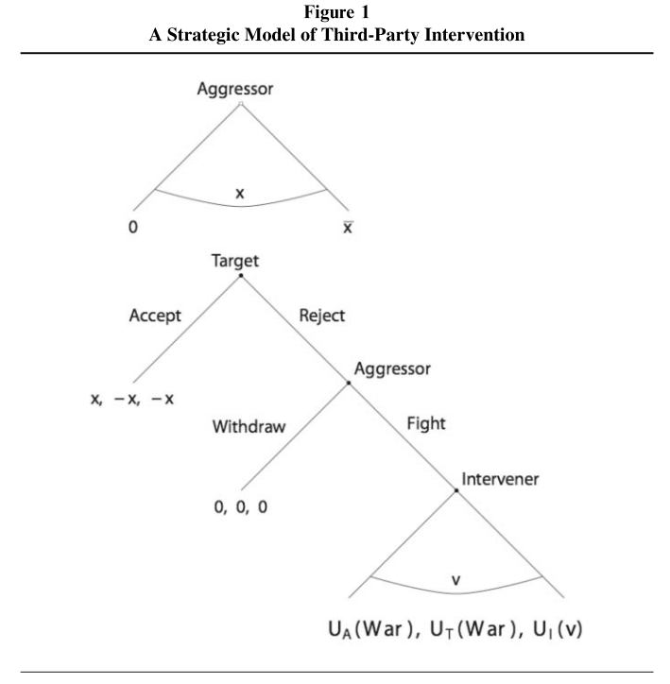

Source: Amy Yuen, Target Concessions in the Shadow of Intervention, Journal of Conflict Resolution, Vol. 53 (2 July 2009) p. 750.

The Figure One shows how the intervener can affect on the target to take a decision and shows the outcomes of the intervention.
Suzanne Werner is addressing the extended deterrence in the name of the three “states”, in my case three players involved in the game – a potential attacker, potential target and the third-party, given this I will not identify attacker and target, assuming those as conflicting parties and third-party, though the third-party credibility strongly affects the attacker’s decision to intervene or not. The whole logic is the outcome of expected costs of war/intervention and the marginal probability of contributing into the victory. The potential third-party identifies for itself the degree of the intervention and the level of thread posed on the sides, that is to say it identifies credibility measures for itself and the level of commitment.
Why I consider the framework applicable to the certain ethnic conflicts is that the EU plays the role of the third-party in the conflict, whereas its role in the South Caucasus is to deter the conflicting parties not to attack. This is a controversial case in the EU engagement in the ethnic conflict resolution process because here it certainly deters all parties not to attack the target country: in the cases of identifying its policy in Transnistria and Cyprus, where the EU has certain biasness and its policy is not equally similarly distributed between the conflicting parties.
Although Yuen has interpreted the model in terms of winning the war, I apply the model to the EU policy in all three conflicts in the region and I do see the results show biased EU intervention will lead to the eruption of war and the results will accordingly be backward up, but if there is no intervention the probability of the conflict to erupt will be p, but when intervention occurs the amount of intervention is higher gaining the value v. In all three conflicts the EU credible intervention would lead to the aforementioned outcomes, to be discussed.
The maximized expected utility of the intervener, when the decision is to be made by the intervener is the
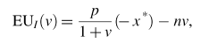
Where n (the slope) indicates that the incremental cost increase of conflict takes place when the intervener increases the amount (size) of his contribution. The interpretation of the slope in the conflict resolution process can be relatively interpreted as the higher the investments in the conflict resolution process, the more likely the outcome will be satisfying the intervener’s aims. The difficulty is how to determine the costs input, intervener’s aims and “defender-aggressor” positions, when there is no official clearly announced biasness in the conflict. Currently the situation in the South Caucasus viewed under the intervention light of the EU is a “status quo payoff of zero.” The decisions of the targets (here Armenia, Azerbaijan, Georgia and Russia) to accept or avoid the intervention demands are becoming more controversial:
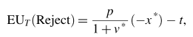
All four targets’ expected utility both for rejecting and accepting demands is almost equal, considering the relatively similar policies and demands presented to all four countries to solve the conflicts, where t is the targets costs of war.
Accordingly the concept that the intervener maximizes its expected utility for intervention is practically true in this case, when the costs of rejecting the intervention are almost equal, meanwhile the more input in the conflict the more the gains will be significant. So far the intervention will take place if v > 0 and the intervener will not intervene in the conflict when the v ≤ 0.
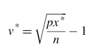
Addressing the question why does the third party find itself locked in the ongoing dispute as an intervener is addressed by Suzanne Werner in her Deterring Intervention: The Stakes of War and Third-Party Involvement. This is a brilliantly argumented work that touches the key variables lying behind the successful third-party intervention in an extended deterrence game model. Though criticizing the argument of Bailey that the intervener takes into account the character of conflict from inside, this can be a very valuable argument, though not the only one that motivates the third-party to intervene. Meanwhile the intervention takes place based on personal interests to balance the situation or to prevent one of the sides to change the status-quo in favor of one of the sides. All those argument cannot be exceptionally valid per se because of backing factors, explicit or implicit that predict the behavior that is not necessarily always rational.
The third-party involvement is interdependent on the strategy used by the conflicting parties: the third-party can alter the parties’ strategy and the conflicting parties can alter the strategy of the third-party used. This is not a constant process and the interaction takes place dynamically at all the phases the conflict appears in.
Traditionally as noted the attacker does not attack because she is deterred by costliness of multilateral war it can appear in, meanwhile it is deterred because the third-party can make the outcome of the bilateral war unprofitable for it, because the third party has private information.

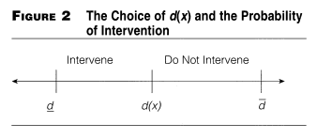
Source: Suzanne Werner, Deterring Intervention: The Stakes of War and Third-Party Involvement, American Journal of Political Science, Vol. 44, No. 4 (Oct., 2000), p. 727.

The extended-deterrence states that the third-party intervention or possible intervention credibly deters the attacker to attack the target. Applied to the scheme of mine based on the extended deterrence, the EU intervention in the South Caucasus keeps the parties deterred from attacking, though EU had committed itself to the resolution of the conflicts of the South Caucasus, whereas it failed in case of deterring the two parties – Georgia and Russia, to get escalate to the eruption of the violent conflict in 2008.

The Realist Theory
In spite of the subdivision made, the realist theory is only defined in this chapter, whereas it is present in each discussion about the geostrategic position of the conflicts and the powers around the conflicts.
Realist Theory according to Deiniol Jones argues that the Great Powers are the main players that determine the state of international security: Great Power can shatter the bases of peace in different points of the world by force or by “geostrategic mediation”. The major-powers, as argued by Renato Corbetta and William Dixon, are different from minor powers: they have material capabilities, their foreign policy interests and activities are different from those that are not powerful players, for this reason major powers find themselves involved in the conflicts more often and drag each other in the conflicts, making a spillover effect in the conflict enlargement process in the rushing competition for more power and resources.
Stefan Wolff indicates that the necessity appears to carefully analyze the actors and the factors that are existent in the context the conflicts emerge, and which can lead to the escalation of the conflict or the peaceful transformation of the conflict to settlement. As noticed by Edward Muller and Erich Weede high rates of growth in the economy reduce the possibility of the political violence occurrence and the separatist tends increase the violence incidence. The rebellion does not take place in vacuum, the rationality of the actors takes into account the costs of the rebellion and the environment.
Often sited idea that partisan intervention, when the intervener strongly takes the side of one of the combatants, becomes a precondition for conflict management altering the current state and the outcome of the conflict, meanwhile this type of intervention intensifies the conflict changing the balance of power and imposing solution that would not have been reached if not the intervention. This is a strong argument though I should note that if EU clarifies its position in the region altering the current status quo, the outcomes will be unpredictably disastrous, so far the interests of other strong powers in the region will clash over the region and shatter the currently relatively stable relations, although the argument stands that the conflict management efforts will be successful in case the third-party clearly defends one of the sides.
Explaining the realist approach to conflict resolution Jonathan Paquin and Stephen Saideman complete the framework by referring to instrumental factors for intervention, that comprise the expected economic gains, military power, calculation of natural resources, regional stabile development and the national security as the indicators of rationality from intervening actors that take action accordingly to their self-interest.

Credibility of Commitment

Garance Genicot and Stergios Skaperdas in their Investing in Conflict Management address the core for my work issue that theoretically describes the commitment problem between the parties in conflict existent situation. Bringing in economic, rational choice and game theory models that tried to find the effects of relationships in a long-term perspective developing measures of commitment between the parties in order to try to overcome the conflict, they argue that cooperation is not necessarily the best outcome in terms of assuring sustainability of equilibrium, where in particular cases cooperative equilibria is fragile than those inducing the eruption of conflict: they additionally and very brilliantly assume in their modeling that there is no guarantee that the institutions of conflict management will necessarily bring success in the process of conflict transformation.
David Lake and Donald Rothchild in Containing Fear: The Origins and Management of Ethnic Conflict approach ethnic conflict not as an outcome of inter-group differences, hatred or the stress of global economy, but because of the fear from safety, difficulty of facing strategic dilemmas that contain potential violence mentioning as background causes information failures, credible commitment problems, security dilemma leading to fear and weakening of state, which bring to potential violence.
The international intervention, although necessary and appropriate, is limited in its effectiveness, meanwhile non-coercive intervention as described by the authors, makes the ethnic groups to be committed to the international norms, raise the costs of conflict occurrence, whereas coercive interventions bring the parties to the table of negotiations and enforce the terms of the outcome artificially raising the costs of the escalation of the conflict or eruption of the conflict.
The main issue in all interventions especially in case of external coercion the credibility of the commitment is the core factor, when intervention may have worse results than no intervention, assuming this competition for resources lies at the heart of ethnic conflicts. The commitment credibility is the core incentive lying under the eruption of violent conflicts, when the “groups cannot credibly commit themselves to uphold mutually beneficial agreements they might reach”, the same according to Fearon theses problems arise when the balance of power shifts, the influence of one side declines and another power appears in the arena. Linking the credible commitment theory to the realist theory of power sharing in the international sphere is associated with the power based muscle politics for gaining dominance over the regions that are sources of potential benefits.
External interventions occur when the states fail to restrain the violence that strategically occurs to protect them from their worst fears: the external intervention that is being divided into non-coercive, coercive and third-party mediation are the forms of third-party intervention that I will contextually refer to in intermixed framework to address the EU policy in the South Caucasus. Non-coercive interventions raise the costs of ethnic appeals and structuring incentives of the leaders of the groups to accept international norms in the meantime external interventions tend to create effects of altering the balance of internal ethnic power.
The term intervention is described by Lake and Rothchild as an enforcement that an outside power poses, providing credible measures which are lacking otherwise, the intervening power can ensure ethnic peace. But the problem with the credibility is that usually credibility can be associated with biasness or the lack of possibility to suffice credible external means of commitment. The referred choice for the third-parties is the noncoercive intervention, that does not intend high costs to be expected, meanwhile in already violent and intense conflicts both coercive and noncoercive measures can dramatically change the situation, by increasing the information and changing the strategies.
Treating conflict management as the outcome of the investments that the sides input in the setting, which may lead to probability of peace and probability of conflict eruption with highly increased levels of investments for increasing the probability of peace, the asset is put on the investments, the relative size of investments and the outcomes of intervention. According to this logic I identify the adversaries of the conflict - Armenia and Azerbaijan, Georgia and Russia and the “butter” as the contested object the territories, over which the conflict has escalated to the degree it exists now. Considering n number of adversaries i ∈ {1, 2, . . ., n} in each period of interaction there is a “butter”, for which the contest is going on, possessing a resource of size R that is the investment for the “butter” in different forms, such as allocation of guns. But this is a two-player game, where the decision makers are the conflicting parties, meanwhile the introduction of other players in the game change the strategies dramatically, when the “butter” becomes highly attractive for the third party. As argued the more the sides invest in the conflict the more the cooperative outcome appears to be available, but the appearance of the third-party as an intervener and its investments, as already mentioned, changes the scope of the game. Particularly the EU intervention in the conflicts of the South Caucasus can be divided into two main strategies: EU intervention, when both conflicting parties are committed and have made investments in the process of resolution and EU intervention when the parties have no incentives to raise the costs of war. Whereas EU policies can also be divided into two main streams: whether the intervention is really credible and committed or not.

EU Conflicting sides
Intervention

Credible Non credible Committed Not committed
to peace settlement to peace settlement

Considering the diagram there can be 4 possible outcomes of the game in each case examined by me, but since I am dealing mainly with the intervention costs and credibility I am not referring to the investments of the conflicting parties and I limit closer examination of in-depth analysis of the cases in terms of assessing local politics. Meanwhile when the conflicting parties have no motivation to come to peace agreement, the efforts of the third-party might fail, or it has to raise the costs of war to avoid the eruption of the conflict, which is dependent on how much is the third-party committed to the conflict consequently it will invest more or not. If m = (m 1 , m 2 , . . ., m n ) is the investment n parties make in the conflict the probability of cooperation function q(m) is a non decreasing and systematic function, because peace requires the participation of all the parties involved in the conflict. When the measure of returns of the investment function is equal to one (α = 1), the probability of peace doubles with the doubling of the investments, but when α < 1, the probability of peace would be achieved by less than double. After the conflicting parties decide the proportions of the investment, perfect Nash equilibrium subgame is being conceptualized. Following this framework if one of the parties does not invest, this will reduce the probability of peace settlement, whereas the more the other invests, the more one is willing to invest to reduce the tension. Clearly seeing that with this the authors face the dilemma where the vicious circle is not open, so far this becomes a game of complete information.
With the increase of the number of the parties in the conflict, the total needed amount of investments increases accordingly, that means the costs of the conflict increase and benefits from investing in the conflict management also increase: this brings to the position when α < 1, the more parties get involved in the conflict, the higher the probability of peace is with the possible outcome of pure cooperation equilibrium.

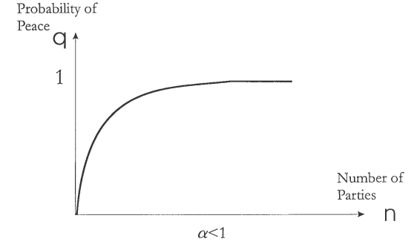

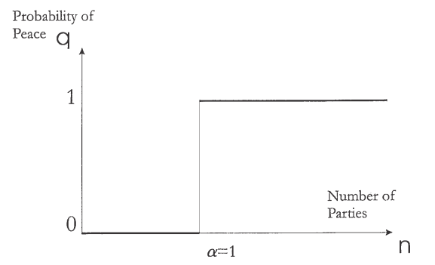

Source: Garance Genicot and Stergios Skaperdas, Investing in Conflict Management, Journal of Conflict Resolution, 2002 46, p. 167.

The framework I do consider presented by the authors though logically stated is rather very fragile, since there is a lack of trying to identify the roles of the third parties and the scope of their involvement in the conflict. The geostrategic and logical chain breaks when the parties involved in the conflict tend to manipulate with the conflicts artificially when the probability of peace decreases since the third-parties invest different costs selectively for the “butter” and make the conflict more intense with the bias. In this case, when the number of n is larger higher level of total resources would be required. Meanwhile the more resources are required the more costly the conflict becomes. Authors conclude their remarks with a judgment that the wealthier the parties are the more likely the peace cooperation equilibrium is to be achieved.
Actually the decision of the third-party to intervene is becoming a reality in a complexity of settings. In a conflict that has already escalated to bloody extreme the intervention of the third party would less likely be successful if the intervening party is not credibly committed to investing massive amounts of resources. The intervention strategy also has impact on the success of intervention, involving the type and the target of the intervention. The major power involvement is the main variable that explains the outcome of the intense conflict to increase the probability of success. While trying to assess cost-benefit calculations, the third-party intervener has to adopt as many pressure points as possible. This raises the value of peace and the party finds itself locked into the committed position to the conflict for the sake of transforming the conflict to peace process.
War is always an inefficient ex post solution which can occur as a result of incomplete information or misassessment of the real potential of the state. Meanwhile the third party before intervening has to have private information about the conflict comprising military economic and political information, strategies and tactics adopted by each side. Territory is usually considered to be the best “butter” that comprising economic resources attracts the states to fight over. Given the framework of William Reed, the absence of economic interdependence of conflicting parties makes the war the best outcome as a solution, so far the cases observed by me highly demonstrate clear isolation of the parties from each other, whereas all 4 parties that are the direct sides of the conflict are economically interdependent with the specific third-party, with the EU, which is viewed as an arbiter in case. For such the Action Plans signed with the three countries of the region and the three parties of conflict recommend economic and political reform aimed at democratization and sustainability.
The role of the third-party is mainly facilitative consulting, but also it is non-coercive and non-directive over outcomes, which is the case with the EU that intervenes without binding rules and methods. Mediation with muscle, defined in the framework of Ronald J. Fisher and Loraleigh Keashly as power mediation involves coercive means of mediation in the form of rewards and punishments that can become beneficial strategies for the success of mediation, the technique that is partially used by the EU in terms of rewards, at the meantime punishment is not a point in the EU agenda towards the countries outside its borders.

Rational Domination via Manipulation

The bargaining theory can become a strong explaining approach inside the conflict manipulation. The theory presented by Charles Boehmer et al explains the war that is a result of certain conditions – material and informational. Mainly diplomatic bargains determine the outcome of the conflicts, but still at the threat of war that often erupts when diplomacy fails. Should we assess that the EU diplomacy in the South Caucasus failed when the war erupted in 2008, would be a fair judgment. Although I have limited my research to only EU involvement examination in the ethnic conflicts of the South Caucasus: namely Nagorno-Karabakh, South Ossetia and Abkhazia, the failure of bargaining can be fairly attributed to other bargaining sides of the conflict. Why I do consider EU was an influential bargaining power in Abkhazian and South Ossetian conflicts is its mission launched in Georgia: EU Rule of Law Mission to Georgia (EUJUST THEMIS) in the context of ESDP in the format of providing assistance to central government and other local bodies aimed at addressing urgent challenges credibly in different spheres such as criminal justice-system, reform implementation, etc. As mentioned by Boehmer et al the IGOs intervention, highly replicable to the third-party intervention general aim, has to be targeted at credibly informing the sides of the conflict or by intervening in a way that will significantly decrease the probability of converting new strategic choices into more explosive demands. Basically in this study the EU intervention effectiveness is the dependent variable. Intervention can significantly alter state behavior: the aim of mine is to observe to what extent can the EU intervention alter the outcome of the state behavior involved in the conflicts, how credible is the EU involved in the conflicts to be able to have an impact on an alteration of state behavior and what are the costs that EU pays for its not yet specified credible intervention to ensure security on the borders. EU is one of the institutions that according to the authors can alter the behavior of the state.
Holley Hansen et al. discuss the role of the International organizations in the process of conflict management and introduce several assumptions that strongly affect the success of the intervention – high institutionalization, homogeneous preferences of the members and democratic members. Though I should highlight that the European Union cannot be associated as an International Organization because of its specificity of decision-making process and the differentiation from the IO structure and form, still the EU has many attributes that can be to some extent identified with the IOs. Considering the variance between the regional and global international organizations, the EU can be more assimilated with the international scope, though with highly fragile definitional bordering.
The stress of mine to refer to this context is the EU possible foreign policy discrepancies that Holley Hansen et al. brilliantly emphasize in their work. So far I will be to some extent replicating their judgments on IOs to EU with strongly argumented background.
From the assumption that the international organizations are more likely to help the conflicting parties to solve their differences when the members of the organization are democratic, when the IO is highly institutionalised and has binding management techniques the limitation I put in case of the EU intervention policy in my specific case is that the EU does not have binding management techniques outside the EU to possibly give incentives for peaceful conflict resolution, not necessarily the binding mechanisms would be efficiently used in the case of internal conflict eruption. Meanwhile I ignore the institutionalization and the democratic members existence because this is not a matter of my current discussion. I also limit my research to considering the homogeneity of preferences of member-states, meanwhile I assume that such homogeneity does not exist, which negatively affects any credible commitment performance by the EU as a sui generis entity to have a decisive role, as it will head to the discussion of EU internal structure and problems.
Though considering the importance of homogeneity of members, citing from Boehmer, Gartzke, and Nordstrom, Holley Hansen et al. argue that informational asymmetries are less likely to occur when the members are homogeneous and the bargaining is better addressed as preferences of the members do not diverge and there are less incentives to reveal information selectively reducing the chance to succeed in the intervention.
Though ideally this is not the case, especially when the EU is the third-party intervening in the ethnic conflicts, when the member states and their preferences are ultimately biased towards selectionist policies making the success of the intervention less likely to occur. Conclusively we can follow that the average preference similarity cannot be noticed in case of the EU intervention policies, not because the intervention is not successful, but because intervention is not clearly defined as a result of not being able to conceptualize the preferences similarly and which leads to the conclusion that the intervention in the specific conflict management process is not successful. ‘‘When actors have heterogeneous interests, issue linkage may generate new opportunities for resolving conflicts and reaching mutually beneficial arrangements. . . . Linkage not only allows states to increase efficiency but may also allow them to overcome distributional obstacles.’’
EU has a strong potential as a third-party actor to mediate the disputes and influence the existing conflict dynamics using the conditionality and socialization. The EU mainly uses passive enforcement tools for conflict transformation, which is distinctly different from the conditionality and rule-bound cooperation whereas in some contexts the EU does not have any power to transform the conflict situations through direct or indirect means.
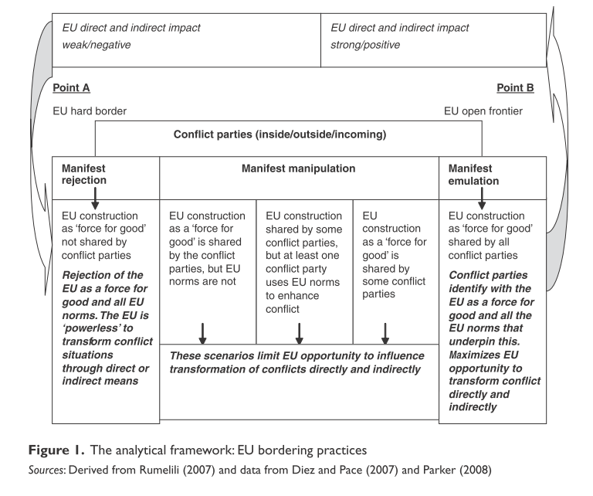
Source: George Christou, The European Union, borders and conflict transformation: The Case of Cyprus, Cooperation and Conflict, 2010 45, p 61.

According to Amy Yuen the bargaining situation is a subject that can be altered by the intervener, shifting the bargaining space that makes cooperation or the status quo more attractive than war in a way of imposing larger demands on the targets in order to produce outcomes referring to settlement. Should I emphasize the European Union as a potential intervener in the conflicts of the South Caucasus, the EU has already shifted the bargaining space to more manipulated field where the lack of possibility to identify its own strategic preferences in the region makes the conflicts more keen to still keeping the status quo as it is, meanwhile the silence does not ensure development to peaceful settlement.
In the region Azerbaijan is considered to be a contributor to EU energy policy and security and the cooperation can be based on oil and gas distribution cooperation, meanwhile this is a very manipulative issue used by Azerbaijan to raise “if we have oil, do we still need Europe?”, whereas this is a perfect source for the EU to ensure its balanced strategy towards the region. More precisely it is more beneficial for the EU to keep the current ceasefire status quo in the region, because other approach might have unexpected results in terms of the escalation of the conflicts and the reaction of the international community, especially the major powers.
Georgia, according to president Saakashvili, is caught in a “zero-sum” game with Russia, where it wants to keep its territorial integrity and deepen the ties with EU and NATO, but the influence of Russia is big in the South Caucasus and it is interested in keeping its role in the region in terms of energy and security policies, at the meantime Russian elites have personal economic interests in Abkhazia, which prevents the EU and the US to get more involved in the region, which have strong commitment but less possibility to do so. Meanwhile there are strong disagreements within the EU towards the protection of one of the sides and the EU commitment, although both the EU and the US are intrinsically supporting the Georgian territorial integrity, which is quite understandable policy in case of US for the balance of power, but EU cannot explicitly support its position because of the discrepancies in its internal politics and the interests of different member-states. The same can be true for the case of Nagorno-Karabakh – the EU is not in a position to express clear view point.

Outcome

To measure the success of the involvement of the EU in the three ethnic conflicts of the region I will use William Ayres’ framework on measuring the success of the conflicts that are divided into three facets:
- Decrease of conflict intensity,
- Increase in communications between parties,
- Reaching of agreements.
Although noted by the author precondition for full conflict resolution as a merged integrity of aforementioned facets, this last point will be not considered in the article, to the extent that currently conflicts are in a state of condition which does not fulfill the requirements of the facets, without proceeding to the full resolution phase.
David Carment and Dane Rowlands state that the use of force by peacekeepers in the intra-state conflict is a function of medium-term strategic interaction, where the decision are being taken on the basis of game-theoretic model, where the utility of the intervention is the outcome of assessing the relationship between the four variables. The variables that lie on the basis for this assessment are the intensity of the mission, the salience of the conflict for the intervener, the involved in the conflict militia’s capabilities and the possible gains from fighting. The intervener’s costs and benefits are strongly connected to its utility of intervention.
Dixon’s approach to cases and strategies employed to stop the conflict refers to different techniques – military, economic and political, that intervener uses. Regan’s framework for interpreting the violent conflict prevention can be significantly applied to third-party intervention in interstate non-violent conflicts that have “frozen” logic and can escalate to violent conflict. Regan states that the intervention strategy’s aim is to alter the calculations of violent conflict and to make it too costly for the sides to continue fighting.
The decision of the third party to escalate is a costly decision, both for the conflicting sides and for the intervening party: the third – party raising the costs may give incentives to more aggressive escalation of the conflict, meanwhile accordingly if one of the sides decides to raise the costs of conflict the intervener, in order to try to make the violent conflict more costly than the peace, has to input higher costs. As brilliantly noted, the third-party intervention should be aimed at bargaining dynamics rather than hostile actions. Should I refer to the EU policy in the South Caucasus I consider it important to note, that the first concern of the authors, that is the ignorance of the question that the intervener wants to or have to input high costs for implementing certain strategies and deployment of forces, can be relatively stated that the EU has committed itself to the resolution of the specified conflicts, where the «want to» part is the outcome of the EU security policy ensuring sustainability on the borders, whereas «have to» is not a satisfied condition as far as the costs input are not significant as in other cases (e.g. Kosovo, Transnistria and Cyprus) in order to deploy forces and ensure strategies.
Referring to the assumptions Carment and Rowlands I have integrated in my framework the assumption that the EU is an actor that is capable of making decisions on the conflicts. I do assume this because EU experience in other conflicts and its capability of establishing peacekeeping forces and missions is a reliable basis to consider that at the presence of will to intervene, the EU can intervene. In my model I consider all the parties as rational-actors, especially referring to the intervener-EU, which rationally finds itself facing the conflicts and commits itself to some extent to the solution of the conflict. The third party intervention can have three forms – no military, which involves mediation efforts, fact finding, preventive diplomacy and sanctions; low-intensity conventional peacekeeping mission and forceful intervention. The first two forms I will consider as being in my case, because the EU does not and did not get involved in the conflicts forcefully. Meanwhile the EUJUST Themis can be considered as a fulfilling the second form intervention: low intensity intervention.
The two-sided game theoretic model is applied by the authors to identify the intensity of intervention: one point should be clearly understand before proceeding to the judgments, the third-party intervenes because it has its own benefits and for this benefits inputs costs in the certain conflict, where the outcome depends both on the costs and the form of intervention. Hence in my work I ignore the fact that the third party can be successful if the conflicting sides believe that the third-party can be successful. The reason why I ignore the fact is a very low civil and political understanding of how EU involvement can become a tool for conflict resolution, hence until the fact that in 2006 Armenia had announced that it is too early for the EU to get involved in the conflict resolution process of Nagorno-Karabakh: the similar idea was expressed by Azeri politicians.
Should I assume according to the authors that the bigger the costs input the higher the successful outcome of the conflict is I would conclude that the EU has to input more efforts while facing the question of intervene or not to intervene and the degree of intervention. «Third parties are assumed to be motivated by the desire to obtain the best outcome at the least cost» and the decision of the intervener to intervene and to what extent is the most problematic dilemma intervener chooses. The game actually starts here, when the intervener's decision to intervene alters the initial game started by the belligerents. The author's framework gives solutions to two strategies, when intervener does not intervene (here the dispute continues and the game ends), when it deploys peacekeeping forces and peace enforcement (where the combatants chose response). The salience of the dispute also predicts the costs needed to be input, the more costly the equilibrium is, the more costs are needed: meanwhile the importance of the dispute is highly connected with the geopolitical and economic importance of the region the conflicts erupt in.
There are 13 different outcomes for the game.

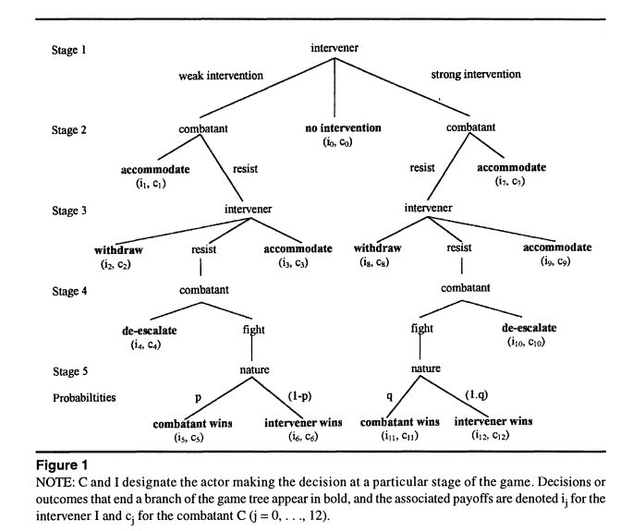
Source: David Carment and Dane Rowlands, Three's Company: Evaluating Third-Party Intervention in Intrastate Conflict, The Journal of Conflict Resolution, Vol. 42, No. 5 (Oct., 1998), p. 583.

During the game each player’s benefit from the outcome and the costs is assessed with assigning values. The exogenous factors in the game are assigned only two values: high and low, after which eight outcomes can be observed. When the rank order of benefits for the outcomes has the combination of Go = G2 = G8 = G5 = G> > G3 = G9 > G4 = G1o > GI = G7 > G6 = G12 for each of the players. In this game it is assumed that the game is a full information game and all the payoffs of the game and strategies are known to the other players and the uncertainty of information is minimized to 0 and both players are risk neutral where the expected outcome of the payoff of other players is comparable. The low intensity intervention only one cooperative solution can be found out in the end, meanwhile high-intensity intervention ends up with four cooperative equilibria. This explains the necessity to emphasize that high intensity intervention is a better strategy for getting credibly involved in the conflict when the aim is to reach a cooperative solution. In the certain model high intensity intervention is the best choice no matter whether the combatants are weak or strong and how significant is the conflict for the intervener. This is how the benchmark game works, showing that the more intensive the intervention is, the higher the probability is that the conflict will have a cooperative outcome.
William Dixon considers two criteria for effectiveness of the third party intervention by assessing the whether the particular management efforts by the third party where aimed and succeeded to prevent the further escalation of the conflict and whether those efforts were giving incentives for the promotion of peace settlements. Picking the approach of Dixon as assumption for the evaluation of EU intervention in the South Caucasus, I will be assessing the success of the EU. Dixon considers international conflict as a clash between the actors’ interests and values. The conflicts have characteristics of escalating and changing the nature and those values and interests can become a matter of change during the time and the number of the actors the conflicts attract. For this Dixon mentions that taking into granted different modes of interaction between the parties conflict transformation can take place in different ways and the nature of the conflicts changes accordingly.

EU intervention assessment
Conflict  Time slot | Abkhazia | South  Ossetia | Nagorno-  Karabakh
1990-1995 | Failure | Failure | Failure
1996- 2000 | Intensity decrease | Intensity decrease | Intensity decrease
2001-2005 | Partial success | Partial success | Partial success
2006-2010 | Failure | Failure | Partial success

Creating the table above which is my assessment of relative EU success-failure dynamics in the region from the 1990s when the conflicts started having more tensioned character and the EU got involved as an intervener after the collapse of the Soviet Union, overall assessment can be generalized as partially successful but not explicitly credible in terms of trying to give solutions.

Conclusion
Assuming that the costly contests have at least two elements, in zero-sum competition and non-zero sum competition the dispute is over the territory that cannot be controlled by two parties simultaneously the conflicts are becoming a matter for intervention, that internationalizes the conflicts and attracts attention of different players to take steps towards altering the conflict transformation strategies. Meanwhile the third party intervenes of its expected utility for intervention outcome exceeds his expected utility of nonintervention outcome.
Concluding the paper I find it important to note that in the context of given assumptions and limitations, I failed to reject the introduced hypothesis, that the efforts of the European Union are not aimed towards the conflict resolution in the South Caucasus, but rather have symbolic character vaguely presented in the Action Plans signed with Armenia, Azerbaijan and Georgia. This is non-rejected hypothesis within the given context that the EU is not credibly committed to the conflict transformation in the South Caucasus firstly because those are not of significant importance appearing to be on the periphery and for this the EU is not credibly committed to addressing the conflicts and altering the outcomes of the dynamism because of the presence of other major players in the region, which will not handle the shift of power: that means the credible intervention and strong commitment may lead to escalation of the conflicts and eruption of war as “the outcome of a diplomatic crisis that cannot be solved because both sides have conflicting estimates of their bargaining power.”
The further research can approach the topic from an angel of trying to introduce other major powers of the region and analyze the dynamics of the conflicts in this complexity.

APPENDIX
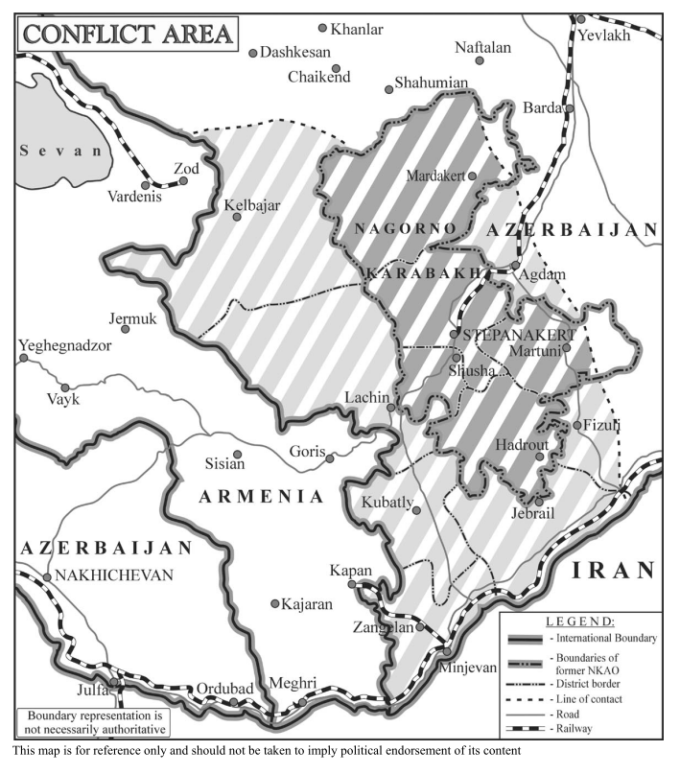
Source: International Crisis group, Nagorno-Karabakh: viewing the conflict from the ground. Europe Report N°166 – 14 September 2005. p. 32.

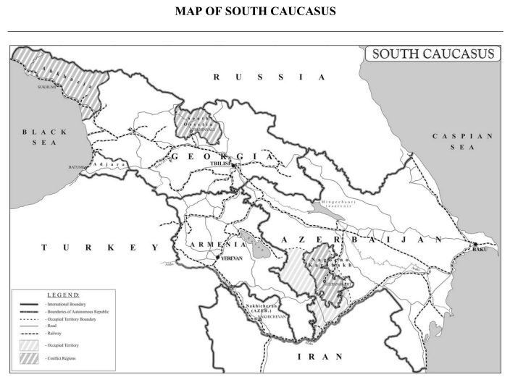

Source: International Crisis Group, Conflict Resolution in the South Caucasus: the EU’s Role, Europe Report N°173 – 20 March 2006, p. 28.
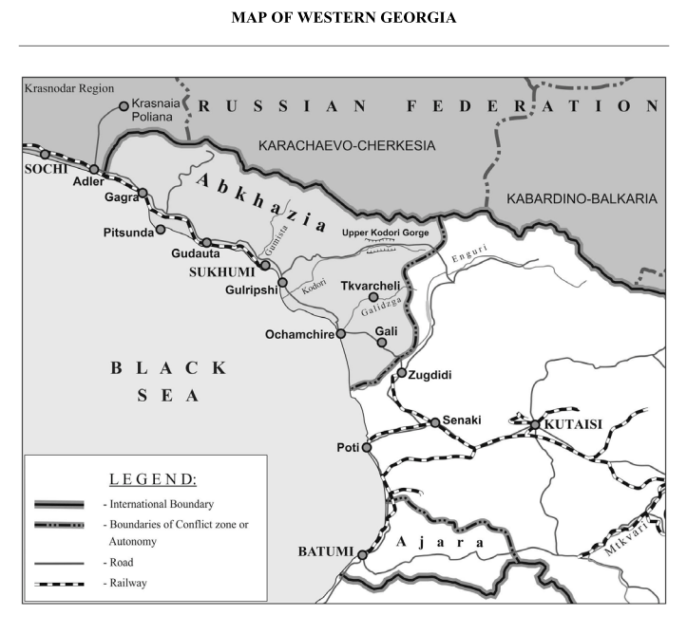 International Crisis Group, Georgia and Russia: Clashing over Abkhazia, Europe Report N°193 – 5 June 2008, p. 25.

Bibliography

- Axelrod, Robert and Robert O. Keohane. Achieving Cooperation under Anarchy: Strategies and Institutions. World Politics, Vol. 38, No. 1 (Oct., 1985), pp. 226-254.
- Ayres, William. Mediating International Conflicts: Is Image Change Necessary? Journal of Peace Research, Vol. 34, No. 4 (Nov., 1997), pp. 431-447.
- Barbé, Esther, Oriol Costa, Anna Herranz, Elisabeth Johansson-Nogués, Michal Natorski, and Maria A. Sabiote. Drawing the Neighbours Closer…to What? : Explaining Emerging Patterns of Policy Convergence between the EU and its Neighbours. Cooperation and Conflict, 2009 44: 378.
- Boehmer, Charles, Erik Gartzke, Timothy Nordstrom. Do Intergovernmental Organizations Promote Peace. World Politics. Volume 57, Number 1, October 2004. pp. 1-38.
- Borg, J. Marian. Conflict Management in the Modern World-System. Sociological Forum. Vol. 7, No. 2 (Jun., 1992), pp. 261-282.
- Carment, David and Dane Rowlands. Three's Company: Evaluating Third-Party Intervention in Intrastate Conflict. The Journal of Conflict Resolution. Vol. 42, No. 5 (Oct., 1998), pp. 572-599. C
- Carment, David and Patrick James. Internal Constraints and Interstate Ethnic Conflict: Toward a Crisis-Based Assessment of Irredentism. The Journal of Conflict Resolution, Vol. 39, No. 1 (Mar., 1995), p. 82-109.
- Christou, George. The European Union, borders and conflict transformation: The Case of Cyprus. Cooperation and Conflict. 2010 45, pp. 55-79.
- Coppieters, Bruno, Michael Emerson, Michel Huysseune, Tamara Kovziridze, Nathalie Tocci, Gergana Noutcheva and Marius Vahl. Europeanisation and Conflict Resolution: Case Studies from the European Periphery. Working papers.
- Corbetta, Renato and William J. Dixon. Danger Beyond Dyads: Third-Party Participants in Militarized Interstate Disputes. Conflict Management and Peace Science: 22, 2005, pp. 39-61.
- Dixon, J. William. Third-Party Techniques for Preventing Conflict Escalation and Promoting Peaceful Settlement. International Organization, Vol. 50, No. 4 (Autumn, 1996). pp. 653-681.
- Fearon, D. James. Rationalist explanations for war. International Organization Vol. 49, No. 3 (Summer 1995), 379-414.
- Fisher, J. Ronald and Loraleigh Keashly. The Potential Complementarity of Mediation and Consultation within a Contingency Model of Third Party Intervention. Journal of Peace Research. Vol. 28. No. 1. Special Issue on International Mediation (Feb. 1991), pp. 29-42.
- Galtung, Johan. Institutionalized Conflict Resolution: A Theoretical Paradigm. Journal of Peace Research. Vol. 2, No. 4 (1965), pp. 348-397.
- Genicot, Garance and Stergios Skaperdas. Investing in Conflict Management. Journal of Conflict Resolution. 2002: 46, pp. 154-170.
- Hansen, E. Holley, Sara McLaughlin Mitchell and Stephen C. Nemeth. IO Mediation of Interstate Conflicts: Moving Beyond the Global versus Regional Dichotomy. Journal of Conflict Resolution 2008. No. 52, pp. 295-325.
- International Crisis Group, Conflict Resolution in the South Caucasus: the EU’s Role, Europe Report N°173 – 20 March 2006.
- International Crisis Group, Georgia and Russia: Clashing over Abkhazia, Europe Report N°193 – 5 June 2008.
- International Crisis Group, Nagorno-Karabakh: A plan for peace, Europe Report N°167 – 11 October 2005
- International Crisis Group. Russia vs Georgia: the Fallout. Europe Report N°195 – 22 August 2008.
- Jones, Deiniol. Cosmopolitan Mediation? Conflict Resolution and the Oslo Accords. Manchester University Press, 1999, p. 34.
- Lake, A. David and Donald Rothchild. Containing Fear: The Origins and Management of EthnicConflict. International Security. Vol. 21, No. 2 (Autumn, 1996), pp. 41-75.
- Muller, N. Edward and Erich Weede. Cross-National Variation in Political Violence: A Rational Action Approach. The Journal of Conflict Resolution. Vol. 34, No. 4 (Dec., 1990), pp. 624-651.
- Nils B. Weidmann. Geography as Motivation and Opportunity : Group Concentration and Ethnic Conflict. Journal of Conflict Resolution. 2009 No. 53, originally published online 27 May 2009, pp. 526-543.
- Ora, Jaap, Frozen conflicts and the EU – a search for a positive agenda.
- Paquin, Jonathan and Stephen M. Saideman. Foreign Intervention in Ethnic Conflicts. March 2008.
- Quackenbush, Stephen L. Not Only Whether but Whom : Three-Party Extended Deterrence. Journal of Conflict Resolution. Vol 50: 2006. pp. 562-583.
- Reed, William. Information and Economic Interdependence. Journal of Conflict Resolution. 2003 47: 54-71.
- Regan, M. Patrick. Conditions of Successful Third-Party Intervention in Intrastate Conflicts. The Journal of Conflict Resolution. Vol. 40, No. 2 (Jun. 1996), pp. 336-359.
- Saideman, M. Stephen. Discrimination in International Relations: Analyzing External Support for Ethnic Groups. Journal of Peace Research, 2002 39: 27.
- Saideman, M. Stephen. Overlooking the Obvious: Bringing International Politics Back into Ethnic Conflict Management. International Studies Review. Vol. 4, No. 3 (Autumn, 2002), pp. 63-86.
- Stewart, J. Emma, ‘The EU as an Actor in Conflict Resolution: Out of its Depth?’
- Sullivan, L. Patricia. At What Price Victory? The Effects of Uncertainty on Military Intervention Duration and Outcome. Conflict Management and Peace Science, 2008 25: 49.
- Wall, A. James and Ann Lynn. Mediation: A Current Review. The Journal of Conflict Resolution, Vol. 37, No. 1 (Mar., 1993), pp. 160-194.
- Werner, Suzanne. Deterring Intervention: The Stakes of War and Third-Party Involvement. American Journal of Political Science. Vol. 44, No. 4 (Oct., 2000), pp. 720-732.
- Wolff, Stefan. Ethnic Conflict: A Global Perspective. Ethnic Conflict. Oxford University Press 2006.
- Yuen, Amy. Target Concessions in the Shadow of Intervention. Journal of Conflict Resolution Vol. 53. 2 July 2009. pp. 745-773.

Deiniol Jones, Cosmopolitan mediation: Conflict Resolution and the Oslo Accords, (Manchester University Press: Manchester UK, 1999.
Erik Melander, The Limits of Manipulation Theory: The Apartheid Third Force and the ANC-Inkatha Conflict in South Africa, Peace Economics, Peace Science and Public Policy: Vol. 8 : Iss. 4, Article 1.
David A. Lake and Donald Rothchild, Containing Fear: The Origins and Management of Ethnic Conflict, International Security, Vol. 21, No. 2 (Autumn, 1996), p. 56.
Stephen M. Saideman. Discrimination in International Relations: Analyzing External Support for Ethnic Groups. Journal of Peace Research, 2002 39, pp. 28-29.
Nils B. Weidmann, Geography as Motivation and Opportunity : Group Concentration and Ethnic Conflict, Journal of Conflict Resolution, 2009 No. 53, originally published online 27 May 2009, pp. 526 - 527.
Johan Galtung, Institutionalized Conflict Resolution: A Theoretical Paradigm, Journal of Peace Research, Vol. 2, No. 4 (1965), p. 348.
Ibid., p. 348.
Wallensteen: 2002, p. 8 in Emma J. Stewart, ‘The EU as an Actor in Conflict Resolution: Out of its Depth?’Working papers, p. 4 .
David A. Lake and Donald Rothchild, Containing Fear: The Origins and Management of Ethnic Conflict, International Security, Vol. 21, No. 2 (Autumn, 1996), p. 42.
Vayrynen in David Carment and Patrick James, Internal Constraints and Interstate Ethnic Conflict: Toward a Crisis-Based Assessment of Irredentism, The Journal of Conflict Resolution, Vol. 39, No. 1 (Mar., 1995), p. 87.
Carment, David and Patrick James. Internal Constraints and Interstate Ethnic Conflict: Toward a Crisis-Based Assessment of Irredentism. The Journal of Conflict Resolution, Vol. 39, No. 1 (Mar., 1995), p. 100.
Amy Yuen, Target Concessions in the Shadow of Intervention, Journal of Conflict Resolution, Vol. 53 (2 July 2009) p. 747.
Marian J. Borg, Conflict Management in the Modern World-System, Sociological Forum, Vol. 7, No. 2 (Jun., 1992), p. 261.
Ibid.
Ibid., 262.
Immanuel Wallerstein, The capitalist world economy, (Cambridge Great Britain: Cambridge University Press, 1980), p. 5
Marian J. Borg, Conflict Management in the Modern World-System, Sociological Forum, Vol. 7, No. 2 (Jun., 1992), p. 276.
Bruno Coppieters, Michael Emerson, Michel Huysseune, Tamara Kovziridze, Nathalie Tocci, Gergana Noutcheva and Marius Vahl, Europeanisation and Conflict Resolution: Case Studies from the European Periphery. Working papers.
International Crisis Group, Conflict Resolution in the South Caucasus: the EU’s Role, Europe Report N°173 – 20 March 2006.
Ibid.
Ibid., pp.2-5.
Ibid., pp.5-6.
Ibid., pp. 9-10.
Ibid., pp. 21-22.
Ibid., pp. 23-24
Stephen L. Quackenbush, Not Only Whether but Whom : Three-Party Extended Deterrence, Journal of Conflict Resolution, Vol 50: 2006, pp. 562-583.
Ibid., pp. 562-563.
Amy Yuen, Target Concessions in the Shadow of Intervention, Journal of Conflict Resolution, Vol. 53 (2 July 2009) p. 746.
Ibid.
Ibid., p. 748.
Amy Yuen, Target Concessions in the Shadow of Intervention, Journal of Conflict Resolution, Vol. 53 (2 July 2009) p. 750.
Suzanne Werner, Deterring Intervention: The Stakes of War and Third-Party Involvement, American Journal of Political Science, Vol. 44, No. 4 (Oct., 2000), p. 721.
Suzanne Werner, Deterring Intervention: The Stakes of War and Third-Party Involvement, American Journal of Political Science, Vol. 44, No. 4 (Oct., 2000), p. 722.
Ibid., p. 723.
Amy Yuen, Target Concessions in the Shadow of Intervention, Journal of Conflict Resolution, Vol. 53 (2 July 2009) p. 750.
Ibid., p. 751.
Ibid.
Ibid.
Ibid., p. 756.
Suzanne Werner, Deterring Intervention: The Stakes of War and Third-Party Involvement, American Journal of Political Science, Vol. 44, No. 4 (Oct., 2000), pp. 720-732.
Ibid., p. 720.
Ibid., p. 721.
Ibid., p. 726-727.
Deiniol Jones, Cosmopolitan Mediation? Conflict Resolution and the Oslo Accords, Manchester University Press, 1999, p. 34.
Renato Corbetta and William J. Dixon, Danger Beyond Dyads: Third-Party Participants in Militarized Interstate Disputes, Conflict Management and Peace Science: 22, 2005, p. 54.
Stefan Wolff, Ethnic Conflict: A Global Perspective, Ethnic Conflict, Oxford University Press 2006.
Edward N. Muller and Erich Weede, Cross-National Variation in Political Violence: A Rational Action Approach, The Journal of Conflict Resolution, Vol. 34, No. 4 (Dec., 1990), p. 625.
Ibid., p. 624.
Renato Corbetta and William J. Dixon, Danger Beyond Dyads: Third-Party Participants in Militarized Interstate Disputes, Conflict Management and Peace Science: 22, 2005, p. 40.
Jonathan Paquin and Stephen M. Saideman, Foreign Intervention in Ethnic Conflicts, March 2008, p.2.
Garance Genicot and Stergios Skaperdas, Investing in Conflict Management, Journal of Conflict Resolution, 2002 46, p. 154.
Ibid., p. 154-155.
Ibid.
Ibid., p. 42.
Ibid., pp. 42-44.
Ibid., pp. 51-58.
Ibid., pp. 64-65.
Ibid., pp. 66-67.
Ibid., p. 68.
Ibid., p. 70.
Garance Genicot and Stergios Skaperdas, Investing in Conflict Management, Journal of Conflict Resolution, 2002 46, p. 155.
Ibid., p. 156.
Ibid.
Ibid.
Ibid.
Ibid., p. 159.
Ibid., p. 163.
Ibid., p. 166.
Ibid., p. 169.
Patrick M. Regan, Conditions of Successful Third-Party Intervention in Intrastate Conflicts, The Journal of Conflict Resolution, Vol. 40, No. 2 (Jun., 1996), p. 347.
Ibid.
Ibid.
Ibid., p. 353.
James D. Fearon, Rationalist explanations for war, International Organization Vol. 49, No. 3 (Summer 1995), 383.
Ibid., 392.
Ibid., 408.
William Reed, Information and Economic Interdependence, Journal of Conflict Resolution, 2003 47: 54-71.
Ronald J. Fisher and Loraleigh Keashly, The Potential Complementarity of Mediation and Consultation within a Contingency Model of Third Party Intervention, Journal of Peace Research, Vol. 28, No. 1, Special Issue on International Mediation (Feb., 1991), p. 32.
Ibid., p. 33.
Charles Boehmer, Erik Gartzke, Timothy Nordstrom, Do Intergovernmental Organizations Promote Peace. World Politics, Volume 57, Number 1, October 2004, p 2.
Ibid.
Council of the European Union, EUJUST-THEMIS, Council Joint Action 2004/523/CFSP of 28 June 2004, http://www.consilium.europa.eu/showPage.aspx?id=701&lang=EN, (accessed 25 September 2010).
Charles Boehmer, Erik Gartzke, Timothy Nordstrom, Do Intergovernmental Organizations Promote Peace. World Politics, Volume 57, Number 1, October 2004, p 2.
Ibid., p 5.
Holley E. Hansen, Sara McLaughlin Mitchell and Stephen C. Nemeth, IO Mediation of Interstate Conflicts : Moving Beyond the Global versus Regional Dichotomy, Journal of Conflict Resolution 2008 52, p. 295.
Ibid., p. 296.
Boehmer, Charles, Erik Gartzke, and Timothy Nordstrom. 2004. Do intergovernmental organizations promote peace? World Politics 57 (1): 1-38 in Holley E. Hansen, Sara McLaughlin Mitchell and Stephen C. Nemeth, IO Mediation of Interstate Conflicts : Moving Beyond the Global versus Regional Dichotomy, Journal of Conflict Resolution 2008 52, p. 301.
Koremenos, Barbara, Charles Lipson, and Duncan Snidal. 2001, The rational design of international institutions, International Organization 55 (4), p. 786 in Holley E. Hansen, Sara McLaughlin Mitchell and Stephen C. Nemeth, IO Mediation of Interstate Conflicts: Moving Beyond the Global versus Regional Dichotomy, Journal of Conflict Resolution 2008 52, p. 302.
George Christou, The European Union, borders and conflict transformation: The Case of Cyprus, Cooperation and Conflict, 2010 45, p. 57.
Ibid.
Amy Yuen, Target Concessions in the Shadow of Intervention, Journal of Conflict Resolution, Vol. 53 (2 July 2009) p. 745.
International Crisis Group, Conflict Resolution in the South Caucasus: the EU’s Role, Europe Report N°173 – 20 March 2006, p. 7.
International Crisis Group, Georgia and Russia: Clashing over Abkhazia, Europe Report N°193 – 5 June 2008, p.13
William Ayres, Mediating International Conflicts: Is Image Change Necessary? Journal of Peace Research, Vol. 34, No. 4 (Nov., 1997), p. 434.
David Carment and Dane Rowlands, Three's Company: Evaluating Third-Party Intervention in Intrastate Conflict, The Journal of Conflict Resolution, Vol. 42, No. 5 (Oct., 1998), p. 573.
Ibid.
William J.Dixon, Third party techniques for preventing conflict escalation and promoting peaceful settlement. International Organization 50: 653-682, 1996 in David Carment and Dane Rowlands, Three's Company: Evaluating Third-Party Intervention in Intrastate Conflict, The Journal of Conflict Resolution, Vol. 42, No. 5 (Oct., 1998), p. 575.
Patrick Regan. Conditions for successful third party intervention in intrastate conflicts. Journal of Conflict Resolution 40: 1996, p. 341 in David Carment and Dane Rowlands, Three's Company: Evaluating Third-Party Intervention in Intrastate Conflict, The Journal of Conflict Resolution, Vol. 42, No. 5 (Oct., 1998), p. 575.
David Carment and Dane Rowlands, Three's Company: Evaluating Third-Party Intervention in Intrastate Conflict, The Journal of Conflict Resolution, Vol. 42, No. 5 (Oct., 1998), pp. 575-576.
Ibid., p. 576.
Ibid.
Ibid., p. 577.
Ibid., p. 580.
Ibid., p. 581.
Ibid., p. 582.
Ibid., p. 584.
Ibid., p. 585.
Ibid., pp. 586-587.
Ibid., p. 588.
Ibid.
Ibid., p. 591.
William J. Dixon, Third-Party Techniques for Preventing Conflict Escalation and Promoting Peaceful Settlement, International Organization, Vol. 50, No. 4 (Autumn, 1996), pp. 654-655.
Ibid., p.655.
Ibid.
Charles Boehmer, Erik Gartzke, Timothy Nordstrom, Do Intergovernmental Organizations Promote Peace. World Politics, Volume 57, Number 1, October 2004, p 8.
Suzanne Werner, Deterring Intervention: The Stakes of War and Third-Party Involvement, American Journal of Political Science, Vol. 44, No. 4 (Oct., 2000), p. 725.
Blainey : 1973, p.114 in Patricia L. Sullivan, At What Price Victory? The Effects of Uncertainty on Military Intervention Duration and Outcome, Conflict Management and Peace Science, 2008 25, p. 50.

